“iMuZiK – REAL TIME MUSIC FEED”

“GRADUATE PROGRAMMING PROJECT”

## By:

Ammar Yasir Ali (893253526)



Professor KENYTT AVERY

# (CPSC 473 - 01)

WEB PROGRAMMING AND DATA MANAGEMENT

College of Engineering & Computer Science California State University, Fullerton

Spring 2016

# TABLE OF CONTENTS

1. REACT JS 1

2. Why React ? 1

**2.1 React.JS Is Extremely Efficient** 1

**2.1 It's Awesome For SEO** 1

**2.3 It Makes Writing JavaScript Easier** 2

**2.4 It Gives You Out-Of-The-Box Developer Tools** 2

2.5 The Brains Behind Facebook Are Maintaining This Project 2

3. Project Description 3

4. GitHub Link 3

5. Installation Instructions 3

6. Application Functionality Screenshots 5

# LIST OF FIGURES

Figure 1: Step 2 3

Figure 2: Step 3 3

Figure 3: Step 4 4

Figure 4: Step 5 4

Figure 5: Step 6 4

Figure 6: Homepage 5

Figure 7: Track 1 6

Figure 8: Track 1 (YouTube) 7

Figure 9: : Track 2 8

Figure 10: Track 2 (YouTube) 9

Figure 11: Track 3 10

Figure 12: Track 3 (YouTube) 11

Figure 13: Track 4 12

Figure 14: Track 4 (YouTube) 13

Figure 15: Track 5 14

Figure 16: Track 5 (YouTube) 15

# 1. REACT JS

**React** (sometimes styled **React.js** or **ReactJS**) is an open-source JavaScript library providing a view for data rendered as HTML. React views are typically rendered using components that contain additional components specified as custom HTML tags. React promises programmers a model in which subcomponents cannot directly affect enclosing components ("data flows down"); efficient updating of the HTML document when data changes; and a clean separation between components on a modern single-page application.

It is maintained by Facebook, Instagram and a community of individual developers and corporations.According to JavaScript analytics service Libscore, **React** is currently being used on the homepages of Netflix, Imgur, Bleacher Report, Feedly, Airbnb, SeatGeek, HelloSign, and others.

# 2. Why React ?

## **2.1 React.JS Is Extremely Efficient**

React.js creates its own virtual DOM where your components actually live. This approach gives you enormous flexibility and amazing gains in performance because React.js calculates what changes need to be made in the DOM beforehand and updates the DOM tree accordingly. This way, React.js avoids costly DOM operations and makes updates in a very efficient manner.

## **2.1 It's Awesome For SEO**

One of the biggest issues with JavaScript frameworks is that they are not exactly search engine friendly. Although there have been some improvements in this area, search engines generally have trouble reading JavaScript-heavy applications.

React.js stands out from the crowd because you can run React.js on the server, and the virtual DOM will be rendered and returned to the browser as a regular web page. No need for PhantomJS and other tricks!

## **2.3 It Makes Writing JavaScript Easier**

React.js uses a special syntax called JSX, which allows you to mix HTML with JavaScript. This is not a requirement – you can still write in plain JavaScript – but I strongly suggest that you try the new syntax because makes writing your components a breeze.

Being able to drop a bit of HTML in your render function without having to concatenate strings is fantastic, and after a while it feels very natural. React.js turns those bits of HTML into functions with a special JSX Transformer.

## **2.4 It Gives You Out-Of-The-Box Developer Tools**

When you start your adventure with React.js, don't forget to install the official React.js chrome extension. It makes debugging your app so much easier.

After you install the extension, you'll have a direct look into the virtual DOM just as if you were browsing a regular DOM tree in the elements panel. Pretty amazing!

## 2.5 The Brains Behind Facebook Are Maintaining This Project

React.js is now open source, but it was first developed at Facebook for internal purposes. After a while, Facebook engineers realized that they created something truly awesome and decided to share their project with the world.

Facebook uses some React.js, and Instagram’s entire website was built on React.js after the two companies joined forces.

# 3. Project Description

This project is a web application where Tracks are being “Scrobbled” from “Spotify, YouTube, SoundCloud” and pretty much every other major music streaming service. A Google Apps Script polls “Last.fm” every minute and logs the tracks to a “Firebase database”. This React component watches that database and renders the five most recent tracks. Clicking on the tracks will direct the user to YouTube video of that track.

# 4. GitHub Link

#### https://github.com/ammaralee/CPSC-473-Grad-Project

# 5. Installation Instructions

1. Install Node.js (https://nodejs.org) or io.js (<https://iojs.org)>
2. git clone https://github.com/ammaralee/CPSC-473-Grad-Project

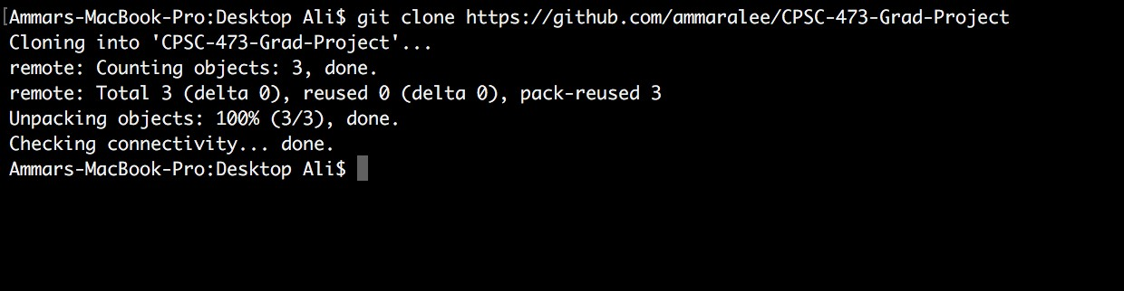

Figure 1: Step 2

#### cd CPSC-473-Grad-Project

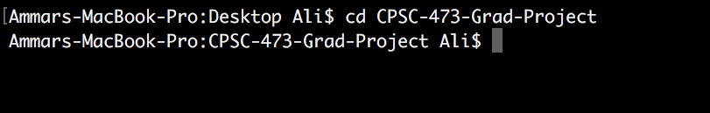

Figure 2: Step 3

1. 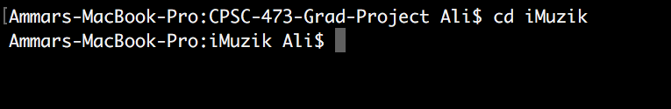cd iMuzik

Figure 3: Step 4

1. 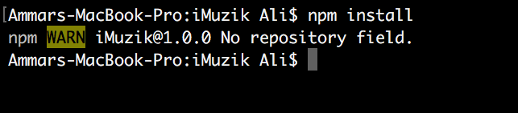npm install

Figure 4: Step 5

Figure 4: Step 5

#### npm start

Figure 5: Step 6

# 6. Application Functionality Screenshots

(On Saturday May 01, 2016)

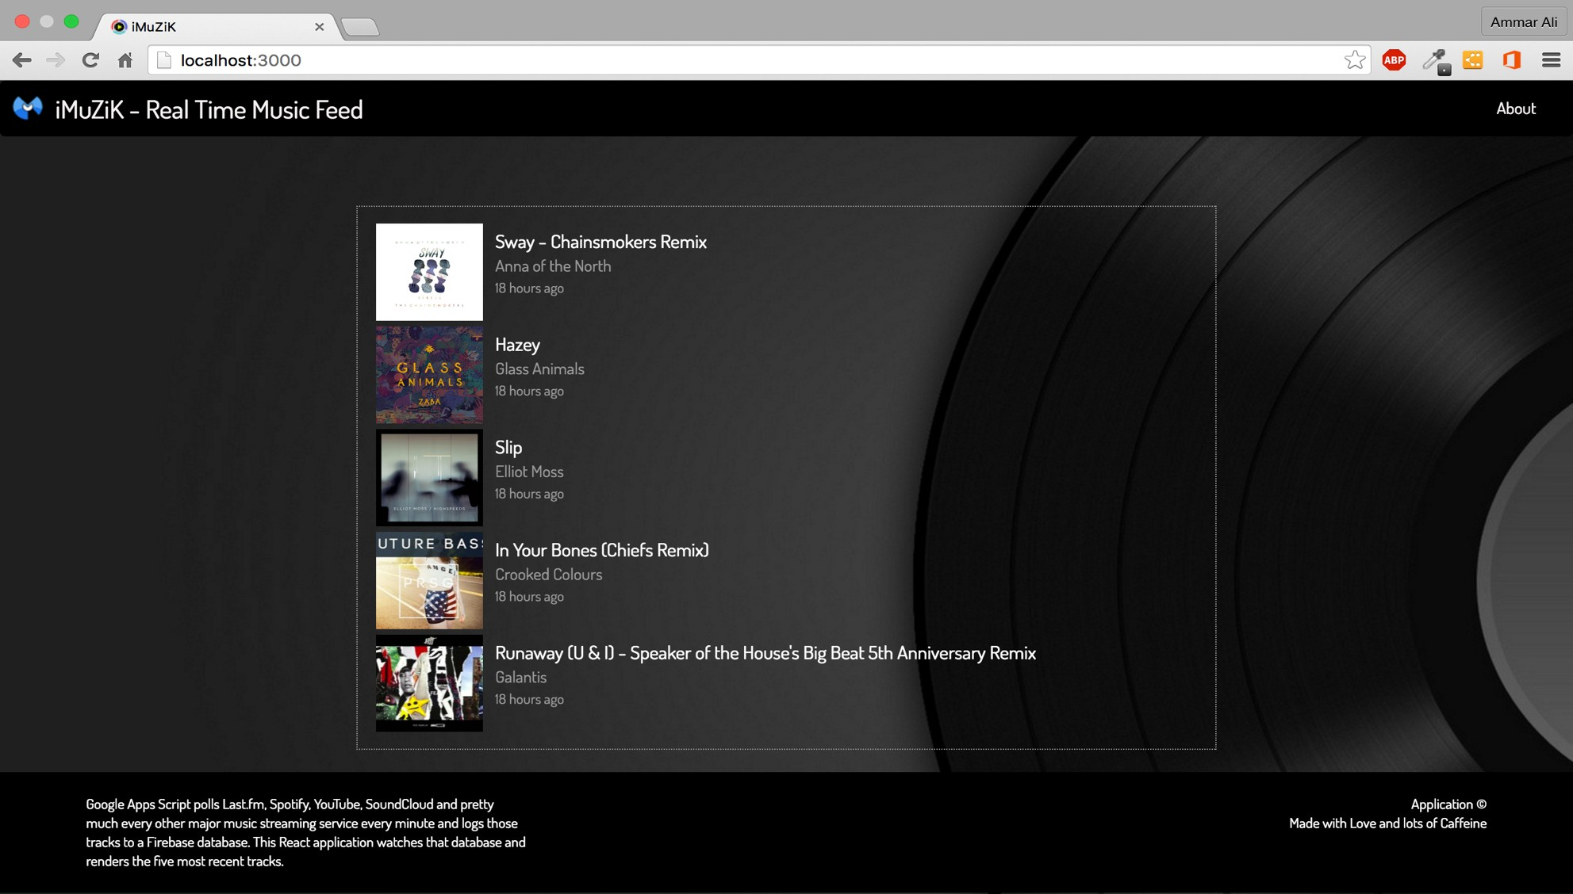Figure 1: Homepage

Figure : Homepage

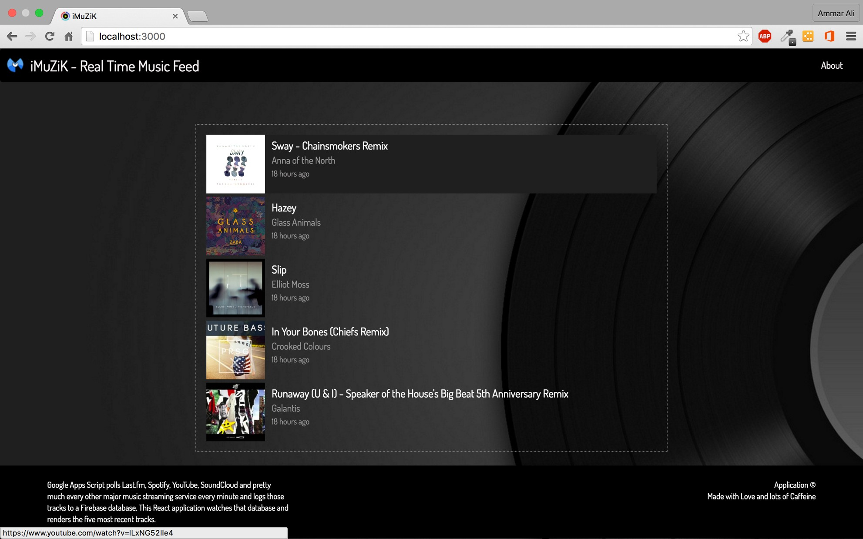

Figure : Track 1

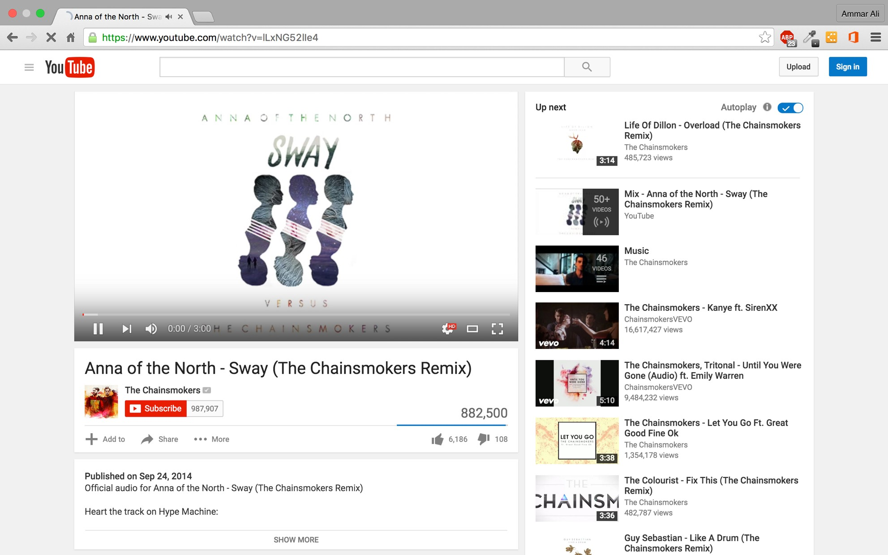

Figure : Track 1 (YouTube)

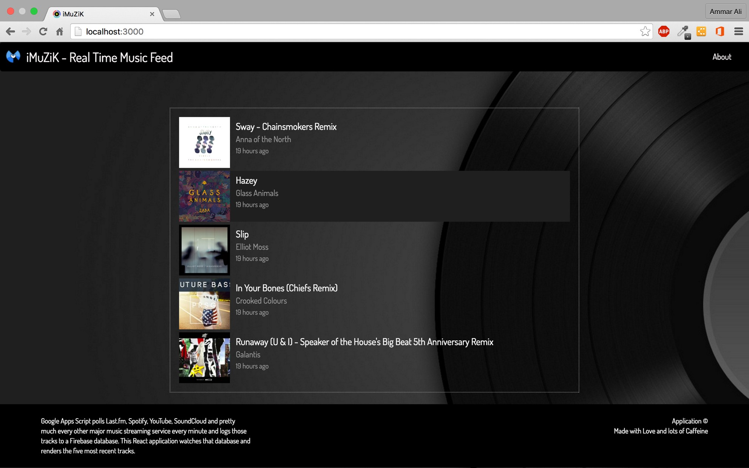

Figure : : Track 2

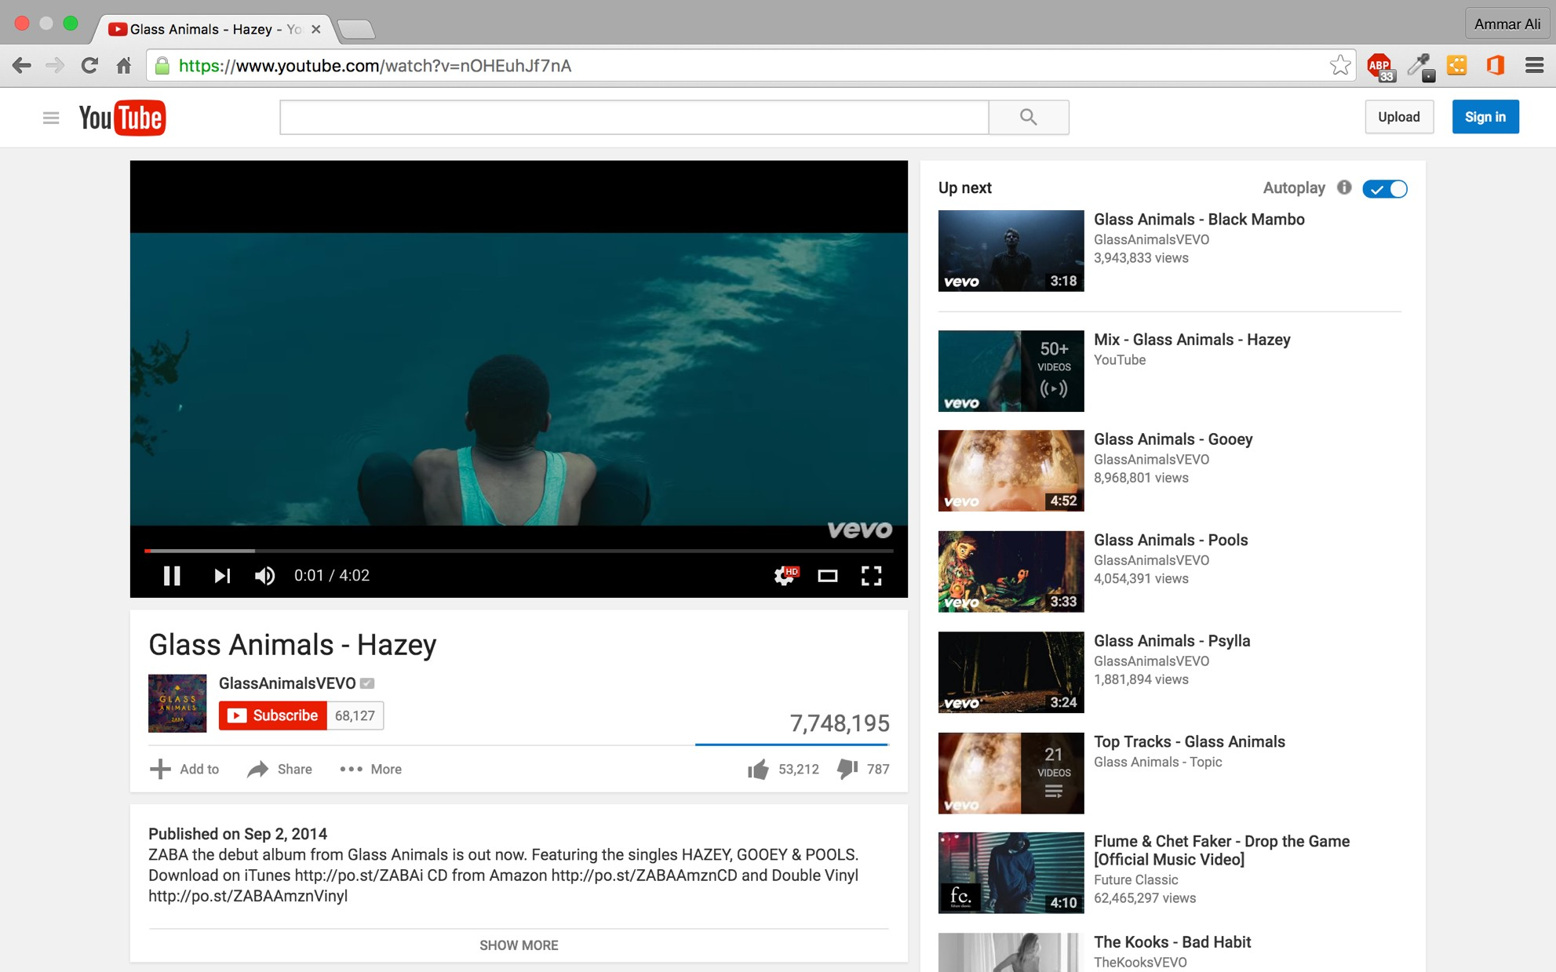

Figure : Track 2 (YouTube)

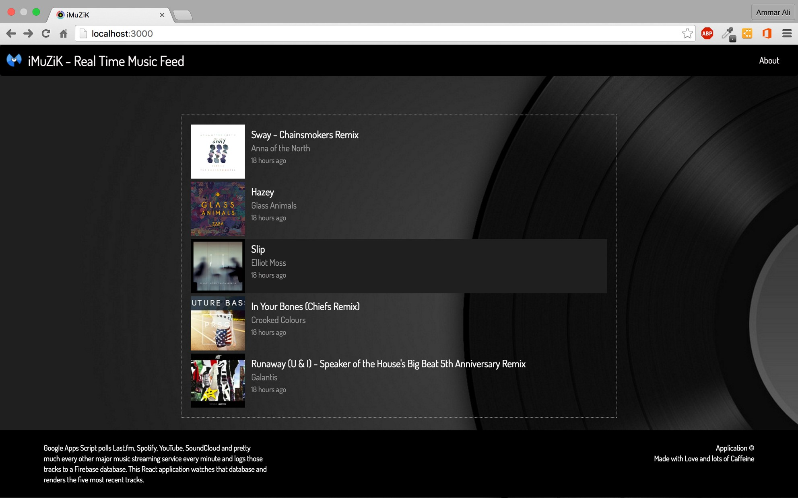

Figure : Track 3

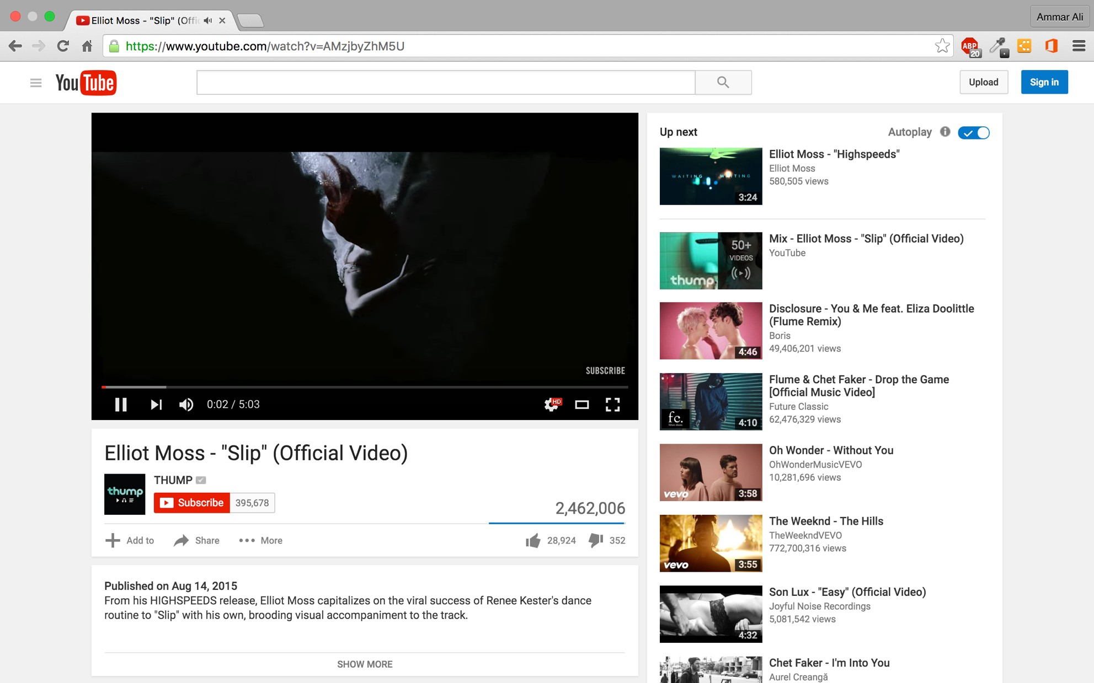

Figure : Track 3 (YouTube)

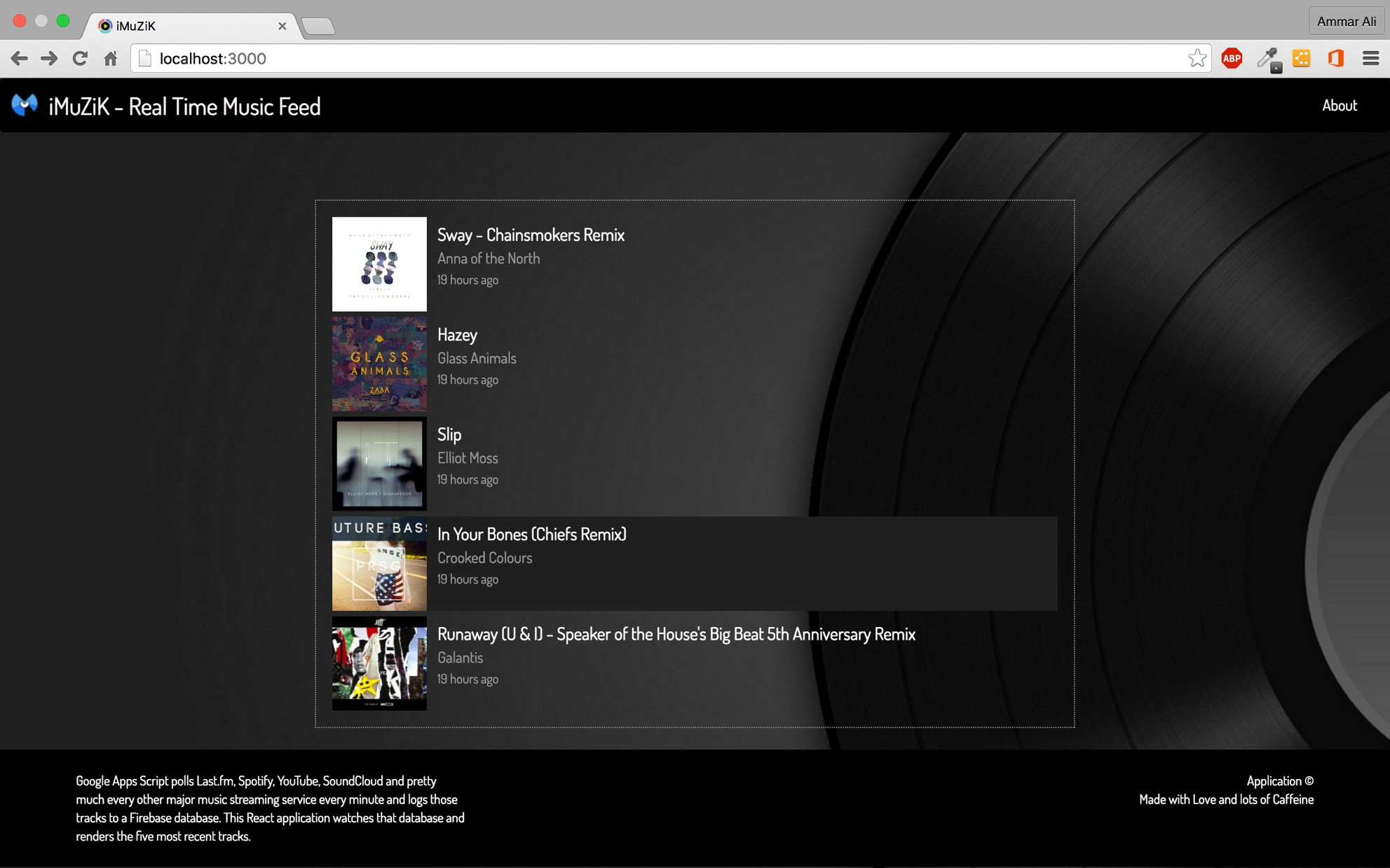

Figure : Track 4

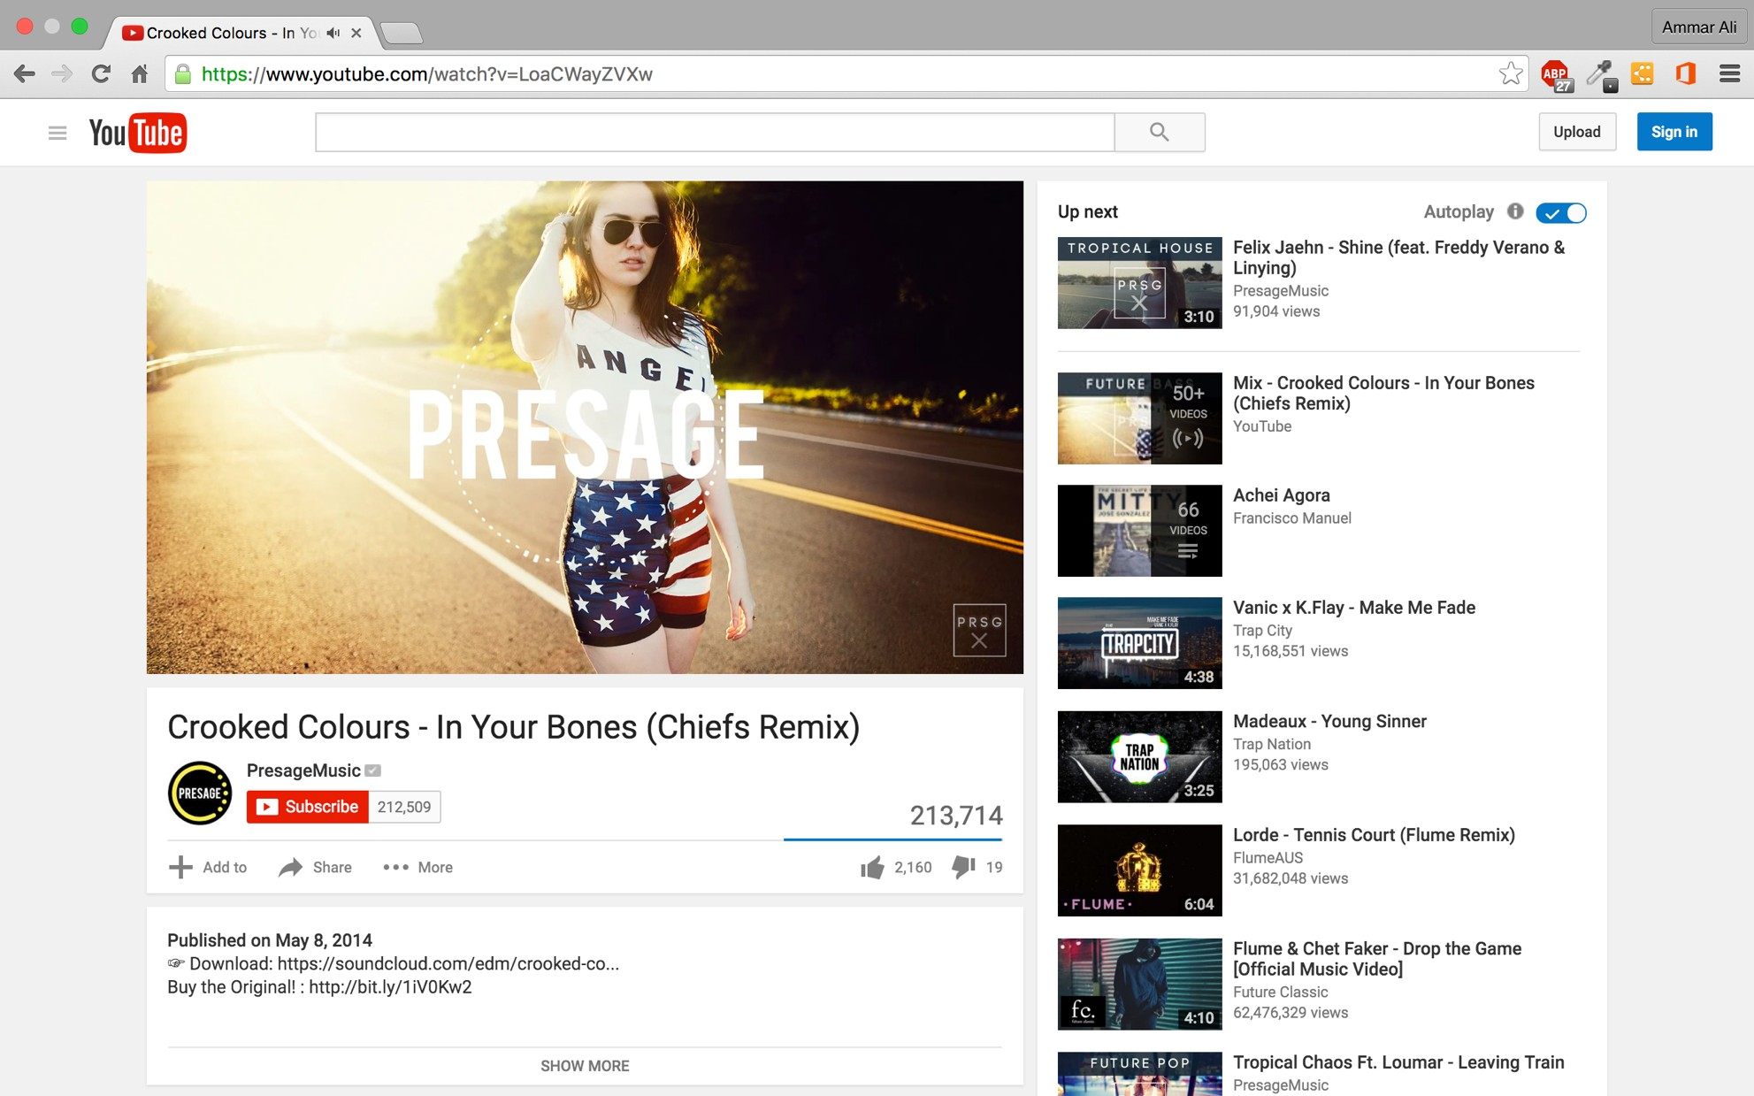

Figure : Track 4 (YouTube)

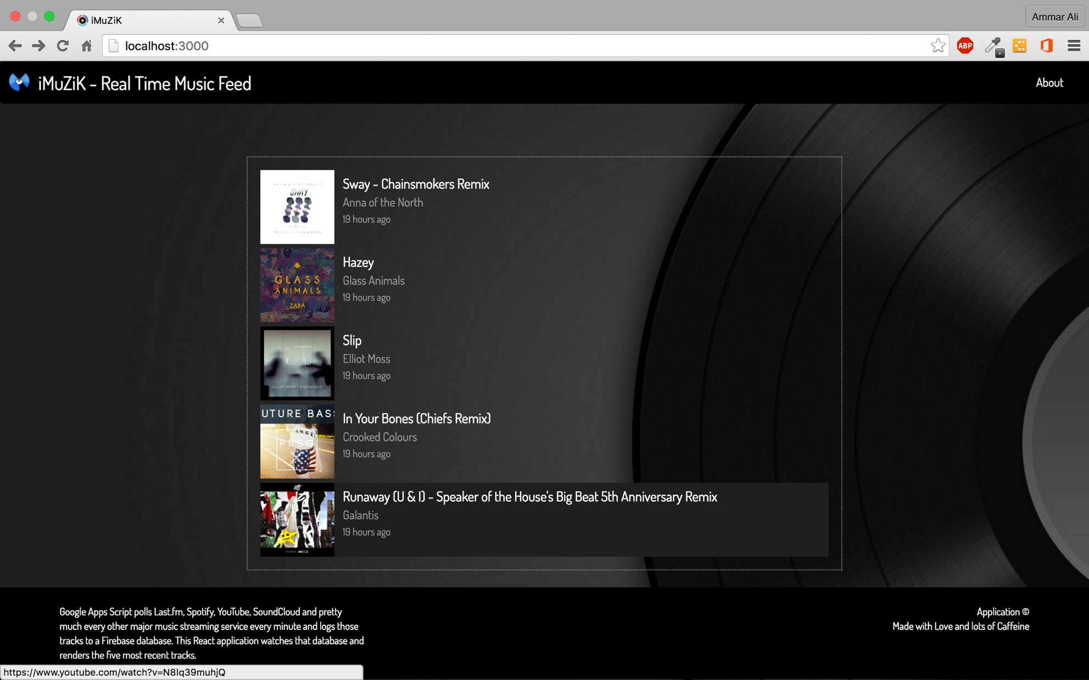

Figure : Track 5

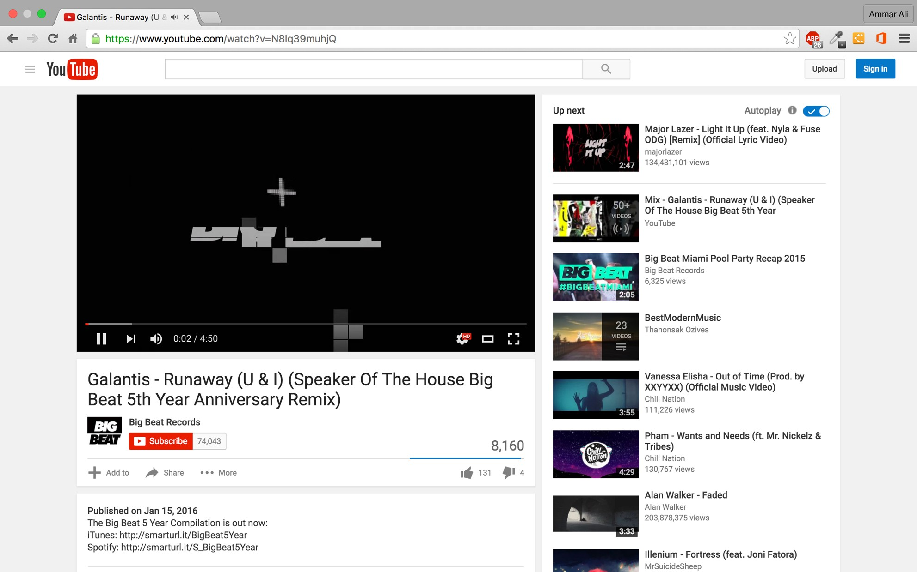

Figure : Track 5 (YouTube)